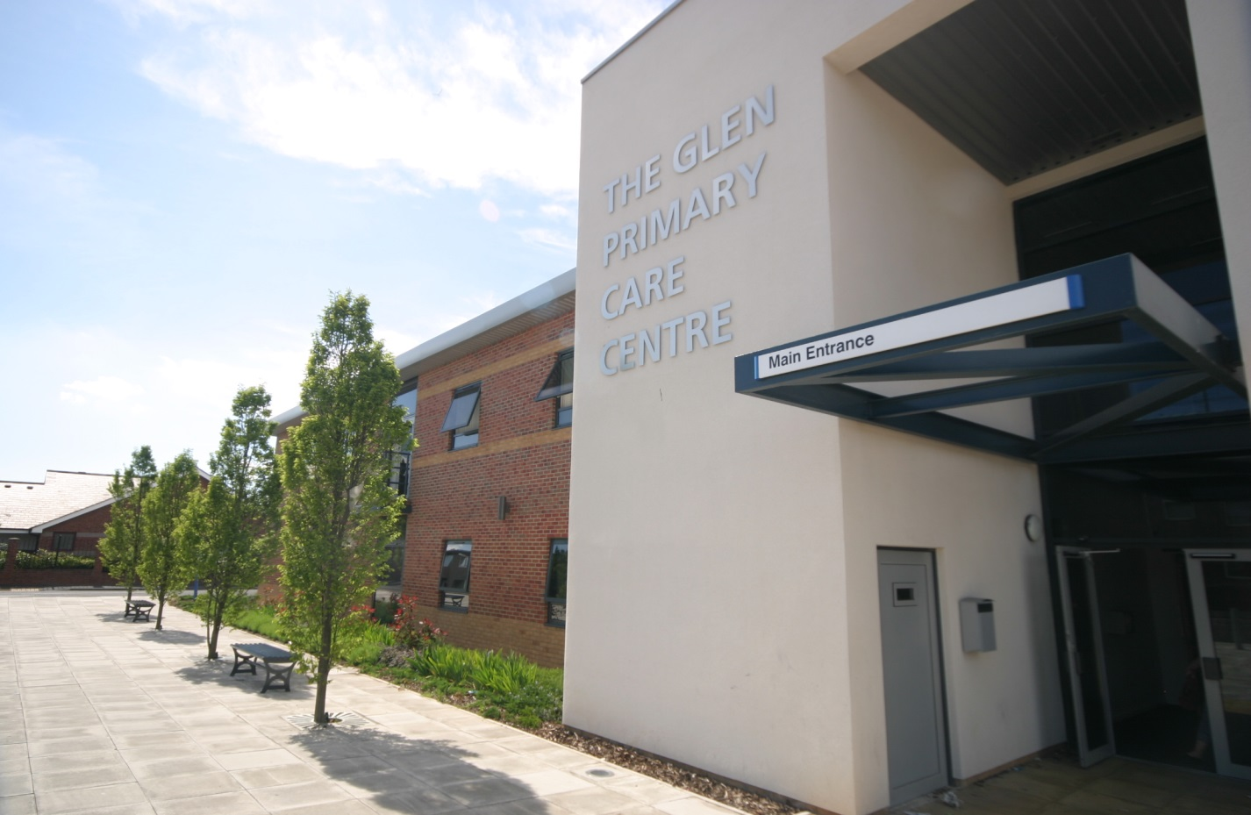

THE GLEN MEDICAL GROUP

Patient Participation Annual Report
March 2019

INTRODUCTION

The history of our Patient Reference Group (previously called the patient forum) is documented in the report published 11/12. Since 2008 we have continued to recruit and develop. The aim of our group continues to be to:
- Share ideas for Practice development with our patients
- Discuss current topics within General Practice
- Assist at Practice open days/Patient Meetings
- Assist in resolving any practice problems
In March 2015 The Glen Medical Group took over the management of The Park Surgery. Both practices are now run side by side from the same premises. It was agreed that it would be more beneficial for the Patient Champions and the Patient Reference Groups from both Practices to join forces. The overall aim is that there is an equitable service provided across both practices and it made sense for a joint collaboration of groups.

Agreement of Priorities 2018/19
Our Patient Reference Group met in June 2018 and agreed some priority areas to look at over the coming year.
As a group we felt priority areas for the practice to work towards improvements were
We agreed the following-

- To improve the information on the call in screen in the waiting room and reduce the amount on the notice boards.
- To have a concentrated promotion of the NHS health checks (members were unaware these were available)
- To implement a new Chronic Disease leaflet for improved patient involvement in their long term conditions.
- To continue from last year with our aim to merge the 2 practices.

We agreed an action plan with aims and actions including responsibilities and timescales for work to be completed – see appendix 1

IMPLEMENTATION OF THE ACTION PLAN

We worked through the action plan and the status of the actions is as follows

Call In screen
A nominated member of the admin team is responsible for and checks the standard information on the call screen each month. We use the NHS seasonal information/Health campaigns and add to this our own practice information as relevant. In addition to this we add weekly ‘Did not attend’ numbers and any further weekly ad hoc information.

Promotion of NHS Health Checks
We aimed to increase the promotion of health checks and continued to actively invite patients after feedback form our PPG that some of them were unaware of the NHS Health check. Our admin team run monthly searches in our clinical system to identify eligible patients for our Health Care assistant to send invites for patients to attend for their NHS Health check. If they do not attend after the first invite the practice does send a reminder.
On reviewing the data for this report we look to have increased our invites from approx. 350 in 17/18 to 498 in 18/19 however we did notice coding issues with the data and our senior admin team are currently looking into this to rectify.

Chronic Disease Patient leaflet
We worked with one of our PPG members who had provided us with a copy of a leaflet used in Gateshead; she explained how she would like to receive this information from a patient perspective, we then adapted it for how we thought it would work in our practice. We did this by meeting with the nursing team to gain their input on how best they felt this would work to benefit both the patients and themselves as the clinicians delivering the chronic disease care.

Merge of 2 Practices
In May 2018 our request to merge the 2 practice was again refused by the CCG and NHS England. The Partners therefore made the difficult decision to request mutual termination of the contract. We felt due to a very difficult 4 years running 2 separate clinical systems which had undoubtedly led to being unable to retain staff both clinical and non-clinical we had no option but to hand the contract for the Park Surgery back to NHS England/CCG.
A closure date of 31^{st March} 2019 was agreed and we worked closely with NHS England to plan the closure. We agreed we would keep the list open for The Glen and register as many patients as wished to move from the Park to the Glen. This was a significant amount of extra work for the practice and was very challenging particularly as it was during winter pressures.
By March 2019 approximately 2000 patients had re registered with the Glen. Approximately 500 patients had not registered anywhere and were therefore allocated a local GP via NHS England – this was done in consultation with local practices and patients were only registered where practices indicated they had capacity to take the extra patients, this included The Glen. There were approximately 300 patients who were either out of the boundary area for The Glen or chose to register elsewhere. The Glen list sze in April 2019 was 10, 100.

PUBLICISING INFORMATION

We publicise this report on our Practice website along with the minutes from our Patient Reference Group meetings.
We also highlight the changes we have made and all the information required for our patients to access these services via our

Practice Leaflet
Quarterly Newsletter
Practice Website
NHS Choices Website
Patient call in screen in waiting room
Poster in waiting room

A Note from The Glen Medical Group

We would like to thank the Patent Participation Group and also the Patient Champion members for their time, commitment and valuable input working with us for continuous improvements to our service.

Appendix 1

The Glen Medical Group
Practice priorities (agreed with PPG) - Action Plan 2018/19 June 18
Title | Aim | Planned action | By Whom | Date to be completed
Call In screen – Improve information | To increase use of screen and improve relevance of information | - To review standard information monthly.  - To add more ad hoc info i.e. weekly DNA rates/changes to services/health campaigns | LC | April 19
NHS Health checks – proactive calling/improved promotion | To improve promotion of Health checks and increase uptake | - To continue to actively call and recall eligible patients for NHS health check but advertise/promote this more widely. | LC | April 19
Chronic Disease leaflet | To introduce a patient leaflet for patients to receive before they attend appointment. | - To review the draft leaflet provided by member of the PPG. To gain clinical input from Practice nurses and agree template for use in practice. | LC | April 19
Merge 2 practices | To continue to work towards merge of 2 practice. | - To appeal to NHS England/CCG decision not to allow us to merge. | LC/Partners | ongoing

